实 验 报 告

辽宁科技大学________计算机与软件工程_______学院 2021年 5 月 30 日
课名：Java框架SpringMVC |  | 实验题目：实验六 Spring 类型转换和格式化
班级：软件18.4 | 姓名: 谢靖萱 |  | 学号：120183503202 | 任课教师：张春娜
实验目的：
1、了解类型转换的意义
2、掌握内置的类型转换器
3、掌握自定义类型转换器
4、掌握内置的格式化转换器
5、掌握自定义格式化转换器
实验内容：
- 实验习题1
解题内容
package com.xjx.controller;

import org.springframework.stereotype.Controller;
import org.springframework.ui.Model;
import org.springframework.web.bind.annotation.RequestMapping;
import org.springframework.web.bind.annotation.RequestParam;

import com.xjx.pojo.GoodsModel;

@Controller
@RequestMapping("/my")
public class ConverterController {
@RequestMapping("/converter")
public String myConverter(@RequestParam("goods") GoodsModel gm,Model model){
model.addAttribute("goods", gm);
return "showGoods";
}
}
package com.xjx.converter;

import org.springframework.core.convert.converter.Converter;

import com.xjx.pojo.GoodsModel;

public class GoodsConverter implements Converter<String,GoodsModel> {
public GoodsModel convert(String source){
GoodsModel goods=new GoodsModel();
String stringValues[]=source.split(",");
if(stringValues!=null && stringValues.length==3){
goods.setGoodsname(stringValues[0]);
goods.setGoodsprice(Double.parseDouble(stringValues[1]));
goods.setGoodsid(Integer.parseInt(stringValues[2]));
return goods;
}else{
throw new IllegalArgumentException(String.format("类型转换失败，需要格式 'apple,10.58,200',但格式是[%s]",source));
}
}
}
package com.xjx.pojo;

public class GoodsModel {
private String goodsname;
private double goodsprice;
private int goodsid;

//public GoodModel(String goodsname, double goodsprice, int goodsid) {
// super();
// this.goodsname = goodsname;
// this.goodsprice = goodsprice;
// this.goodsid = goodsid;
//}
//
//public GoodModel() {
// super();
//}

public String getGoodsname() {
return goodsname;
}
public void setGoodsname(String goodsname) {
this.goodsname = goodsname;
}
public double getGoodsprice() {
return goodsprice;
}
public void setGoodsprice(double goodsprice) {
this.goodsprice = goodsprice;
}
public int getGoodsid() {
return goodsid;
}
public void setGoodsid(int goodsid) {
this.goodsid = goodsid;
}

}
XML：
<?xml version="1.0" encoding="UTF-8"?>
<beans xmlns="http://www.springframework.org/schema/beans"
xmlns:xsi="http://www.w3.org/2001/XMLSchema-instance" xmlns:mvc="http://www.springframework.org/schema/mvc"
xmlns:context="http://www.springframework.org/schema/context"
xsi:schemaLocation="http://www.springframework.org/schema/beans
http://www.springframework.org/schema/beans/spring-beans.xsd
http://www.springframework.org/schema/context
http://www.springframework.org/schema/context/spring-context.xsd
http://www.springframework.org/schema/mvc
http://www.springframework.org/schema/mvc/spring-mvc.xsd">
<context:component-scan base-package="com.xjx.controller" />
<bean id="conversionService"
class="org.springframework.context.support.ConversionServiceFactoryBean">
<property name="converters" >
<list>
<bean class="com.xjx.converter.GoodsConverter" />
</list>
</property>
</bean>
<mvc:annotation-driven conversion-service="conversionService"/>
<bean
class="org.springframework.web.servlet.view.InternalResourceViewResolver"
id="internalResourceViewResolver">
<property name="prefix" value="/WEB-INF/jsp/"></property>
<property name="suffix" value=".jsp"></property>
</bean>
</beans>
Index：<%@ page language="java" contentType="text/html; charset=utf-8"
pageEncoding="utf-8"%>
<!DOCTYPE html PUBLIC "-//W3C//DTD HTML 4.01 Transitional//EN" "http://www.w3.org/TR/html4/loose.dtd">
<html>
<head>
<meta http-equiv="Content-Type" content="text/html; charset=utf-8">
<title>index</title>
</head>
<body>
<form action="${pageContext.request.contextPath }/my/converter" method="post">
请输入商品信息(格式为apple,10.58,200)：
<input type="text" name="goods" /><br/>
<input type="submit" value="提交" />

</form>

</body>
</html>
<%@ page language="java" contentType="text/html; charset=utf-8"
pageEncoding="utf-8"%>
<!DOCTYPE html PUBLIC "-//W3C//DTD HTML 4.01 Transitional//EN" "http://www.w3.org/TR/html4/loose.dtd">
<html>
<head>
<meta http-equiv="Content-Type" content="text/html; charset=utf-8">
<title>showGoods</title>
</head>
<body>
您创建的商品信息如下：<br>
商品名称为：${goods.goodsname },
商品价格为：${goods.goodsprice},
商品数量为： ${goods.goodsid }.
购买者：谢靖萱
</body>
</html>
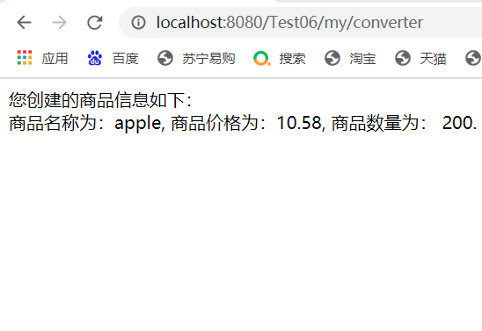
- 实验习题2
解题内容
package com.xjx.controller;

import org.springframework.stereotype.Controller;
import org.springframework.ui.Model;
import org.springframework.web.bind.annotation.RequestMapping;

import com.xjx.pojo.GoodsModelb;

@Controller
@RequestMapping("/my")
public class FormatterController {
@RequestMapping("/formatter")
public String myConverter(GoodsModelb gm, Model model){
model.addAttribute("goods", gm);
return "showGoods";
}
}
package com.xjx.formatter;

import java.text.ParseException;
import java.text.SimpleDateFormat;
import java.util.Date;
import java.util.Locale;

import org.springframework.format.Formatter;

public class MyFormatter implements Formatter<Date> {
SimpleDateFormat dateFormat=new SimpleDateFormat("yyyy-MM-dd");

@Override
public String print(Date object, Locale arg1) {
// TODO Auto-generated method stub
return dateFormat.format(object);
}

@Override
public Date parse(String source, Locale arg1) throws ParseException {
// TODO Auto-generated method stub
return (Date) dateFormat.parseObject(source);
}

}
package com.xjx.pojo;

import java.util.Date;

public class GoodsModelb {
private String goodsname;
private double goodsprice;
private int goodsid;
private Date goodsdate;
public String getGoodsname() {
return goodsname;
}
public void setGoodsname(String goodsname) {
this.goodsname = goodsname;
}
public double getGoodsprice() {
return goodsprice;
}
public void setGoodsprice(double goodsprice) {
this.goodsprice = goodsprice;
}
public int getGoodsid() {
return goodsid;
}
public void setGoodsid(int goodsid) {
this.goodsid = goodsid;
}
public Date getGoodsdate() {
return goodsdate;
}
public void setGoodsdate(Date goodsdate) {
this.goodsdate = goodsdate;
}

}
XML：
<?xml version="1.0" encoding="UTF-8"?>
<beans xmlns="http://www.springframework.org/schema/beans"
xmlns:xsi="http://www.w3.org/2001/XMLSchema-instance" xmlns:mvc="http://www.springframework.org/schema/mvc"
xmlns:context="http://www.springframework.org/schema/context"
xsi:schemaLocation="http://www.springframework.org/schema/beans
http://www.springframework.org/schema/beans/spring-beans.xsd
http://www.springframework.org/schema/context
http://www.springframework.org/schema/context/spring-context.xsd
http://www.springframework.org/schema/mvc
http://www.springframework.org/schema/mvc/spring-mvc.xsd">
<context:component-scan base-package="com.xjx.controller" />
<bean id="conversionService"
class="org.springframework.format.support.FormattingConversionServiceFactoryBean">
<property name="formatters" >
<set>
<bean class="com.xjx.formatter.MyFormatter" />
</set>
</property>
</bean>
<mvc:annotation-driven conversion-service="conversionService"/>
<bean
class="org.springframework.web.servlet.view.InternalResourceViewResolver"
id="internalResourceViewResolver">
<property name="prefix" value="/WEB-INF/jsp/"></property>
<property name="suffix" value=".jsp"></property>
</bean>
</beans>
Index：
<%@ page language="java" contentType="text/html; charset=UTF-8"
pageEncoding="UTF-8"%>
<!DOCTYPE html PUBLIC "-//W3C//DTD HTML 4.01 Transitional//EN" "http://www.w3.org/TR/html4/loose.dtd">
<html>
<head>
<meta http-equiv="Content-Type" content="text/html; charset=UTF-8">
<title>Insert title here</title>
</head>
<body>
<form action="${pageContext.request.contextPath }/my/formatter" method="post">
商品名称：<input type="text" name="goodsname"/><br>
商品价格：<input type="text" name="goodsprice"/><br>
商品数量：<input type="text" name="goodsid"/><br>
商品日期：<input type="text" name="goodsdate"/><br>
<input type="submit" name="提交"/>
</form>
</body>
</html>
<%@ page language="java" contentType="text/html; charset=UTF-8"
pageEncoding="UTF-8"%>
<!DOCTYPE html PUBLIC "-//W3C//DTD HTML 4.01 Transitional//EN" "http://www.w3.org/TR/html4/loose.dtd">
<html>
<head>
<meta http-equiv="Content-Type" content="text/html; charset=UTF-8">
<title>Insert title here</title>
</head>
<body>
您创建的商品信息如下：<br/>
商品名称为：${goods.goodsname }<br>
商品价格为：${goods.goodsprice }<br>
商品数量为：${goods.goodsid }<br>
商品日期为：${goods.goodsdate }<br>
购买用户：谢靖萱
</body>
</html>
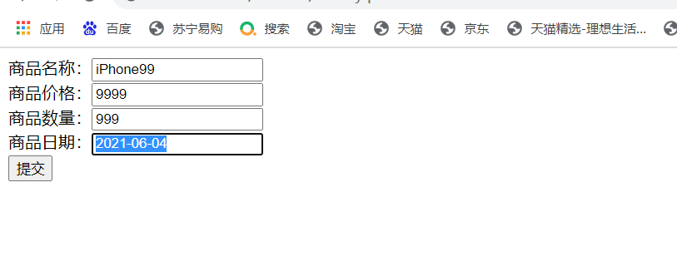
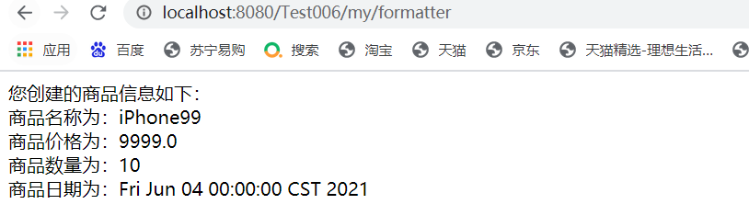
实验心得：
通过这次实验，我学了Spring 类型转换和格式化，类型转换和格式化都是将一种类型转化成另一种类型，创建自定义类型转换器，只需要实现该接口，需要保证转换器是线程安全的。很开心！！
评语：

优：态度认真，遵守纪律，能很好的完成实验内容要求，全面的掌握了专业知识和专业技能，报告结构合理，逻辑很清晰，格式符合规范。
良：态度认真，遵守纪律，能较好完成实验内容要求，较好的掌握了专业知识和专业技能，报告结构合理，逻辑比较清晰，格式符合规范。
中：态度比较认真，遵守纪律，能按时完成实验内容要求，较好的掌握了专业知识和专业技能，报告结构基本合理，逻辑比较清晰，格式基本符合规范。
及格：态度比较认真，遵守纪律，基本能按时完成实验内容要求，基本掌握了专业知识和专业技能，报告结构基本合理，逻辑基本清晰，格式基本符合规范。
不及格：态度不认真，不遵守纪律，不能按时完成实验内容要求，不能掌握专业知识和专业技能，文字不通顺，逻辑不清晰，格式不符合规范。

